**YOLOv8**

# **Original dataset**

With epochs 100

424 images – 305 – 102 - 17

Metrics Graphs –

Train Graphs –

Val Graphs –

# **All dataset**

With epochs 100

1696 photos

Metrics Graphs –

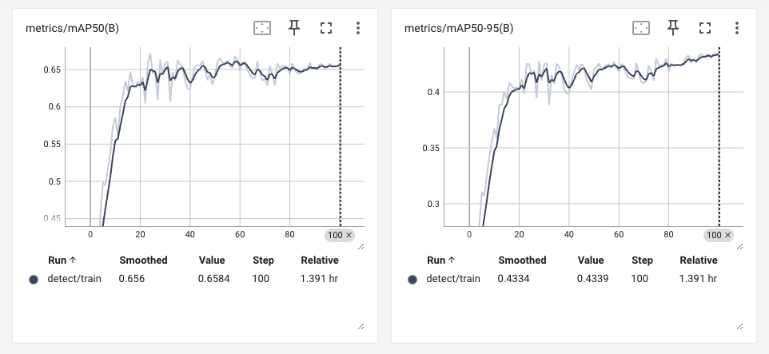

Train Graphs –

Val Graphs –

# **Midnight**

With epochs 100

424 images – 305 – 102 - 17

Metrics Graphs –

Train Graphs –

Val Graphs –

# **Grayscale**

With epochs 100

424 images – 305 – 102 - 17

Metrics Graphs –

Train Graphs –

Val Graphs –

# **Blur**

With epochs 100

424 images – 305 – 102 - 17

Metrics Graphs –

Train Graphs –

Val Graphs –

Faster R-CNN

# **Original Dataset**

# **Midnight**

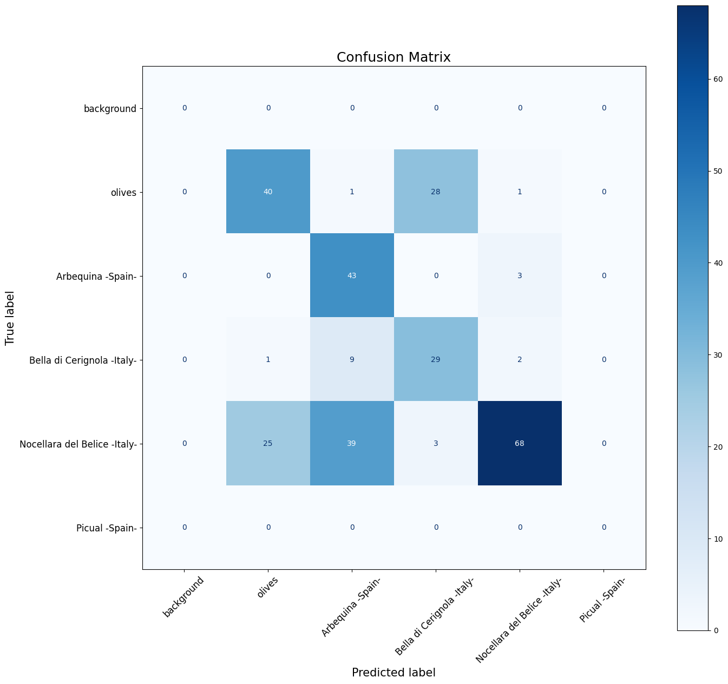

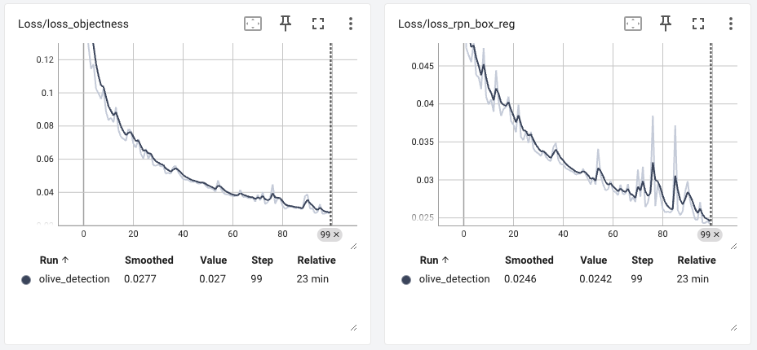

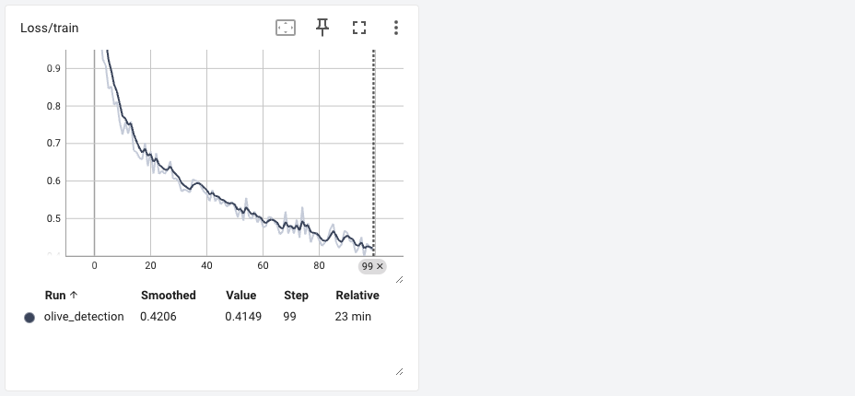

# **Grayscale**

# **Blur**

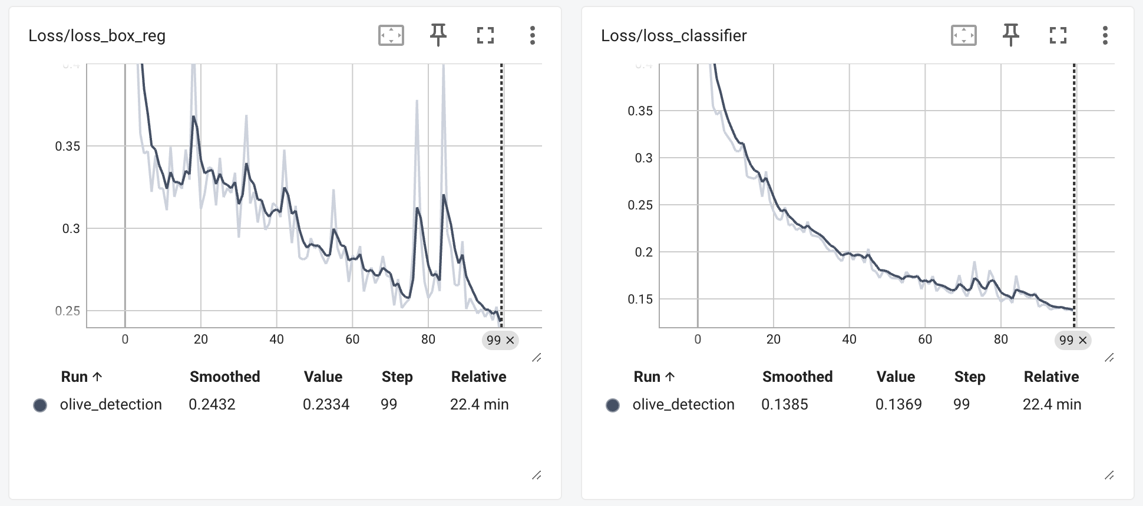

# **All Dataset**

